FrameFusion – Low-Light Image Enhancement for CCTV Feeds using Multi-Frame Motion-Aware Fusion

Project Idea
CCTV cameras deployed in low-light conditions often produce noisy, blurry, and poorly illuminated video frames. Such degradations reduce visibility and compromise the reliability of surveillance systems. Standard single-frame enhancement techniques like histogram equalization or denoising often amplify noise or fail to recover meaningful details.
This project focuses on enhancing CCTV feeds by merging three consecutive frames into one motion-compensated, high-quality frame. The approach leverages temporal redundancy to suppress noise, improve contrast, and produce visually clearer frames. A motion-aware fusion strategy ensures that static regions benefit from multi-frame averaging while moving regions are preserved to prevent ghosting artifacts. Although this reduces the effective frame rate, the resulting frames are more useful for both human observers and downstream computer vision tasks.

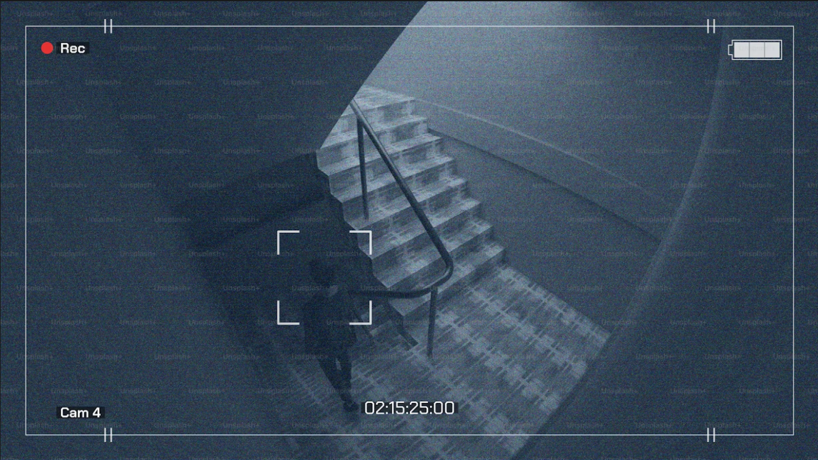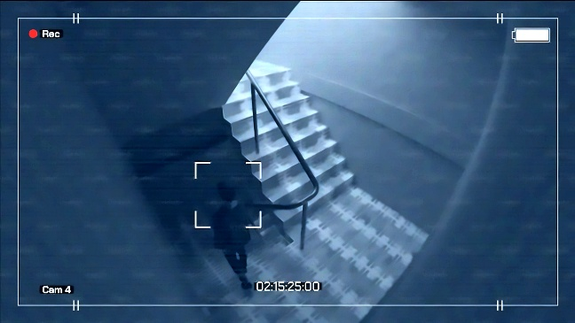
Fig 1: Sample image with noise,
motion blur

Fig 2: Enhanced image with reduced noise and motion blur

Image Courtesy: Cctv footage shows stairs in a dark hallway. photo – Security Image on Unsplash

Features of the Project
1. Frame Preprocessing
- Convert input frames to luminance–chrominance color space (HSV).
- Apply mild spatial filtering to stabilize features before alignment.

- Frame Alignment
- Use feature-based alignment (ORB + RANSAC for affine transform) or dense optical flow.
- Warp neighbouring frames to the reference frame for pixel-wise correspondence.
- Motion Segmentation
- Compute inter-frame differences to detect moving regions.
- Generate binary motion masks and refine them using morphological operations.
- Prevent ghosting by excluding moving pixels from multi-frame fusion.
- Photometric Normalization
- Apply histogram matching or mean–variance normalization to align brightness levels of neighbouring frames with the reference.
- Handle variations caused by auto-exposure in CCTV cameras.
- Multi-Frame Fusion
- Static Regions: Fuse pixels using temporal median or weighted exposure-based fusion.
- Moving Regions: Preserve pixels from the reference frame to maintain clarity.
- Optionally: Apply Laplacian pyramid multi-scale blending for natural transitions.
- Post-Processing
- Enhance local contrast using CLAHE.
- Apply bilateral or non-local means denoising for residual noise suppression.
- Perform gamma correction and light sharpening (unsharp masking) to improve detail.
- Frame Scheduling
- Output enhanced frames at reduced frame rate (e.g., 20-25 fps from 30 fps input).
- Maintain temporal consistency across consecutive outputs.
- Visualization & Comparison
- Provide side-by-side comparisons of original, single-frame enhanced, and fused frames.
- Plot histograms to demonstrate contrast improvement and noise reduction.
- Quality Evaluation Metrics
- Measure quantitative improvements using:
  - SNR / variance analysis on uniform dark regions.
  - NIQE/BRISQUE for no-reference image quality assessment.
  - Edge strength (Tenengrad, Laplacian variance) to validate detail preservation.
- Color Frame Enhancement
- Extend fusion from luminance-only to full RGB processing.
- Apply fusion on Y channel, while chrominance channels are preserved or lightly averaged to maintain natural color.

